Guide to Shimadzu UV-VIS
Spectrum Acquisition

- Turn on the instrument by flipping the switch on the left-hand side. Wait about 5 minutes for the lamps to warm up.
- Open the UV Probe software by double-clicking the icon on the desktop 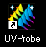
- Click on the Connect button 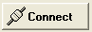. The instrument will initialize and do a series of performance checks, which takes about 5-10 minutes to complete. All the boxes should be green when this is done. Click “OK” when it is complete.
- Click on the Spectrum mode icon or click on Windows → Spectrum.
- To set up your acquisition parameters, click on the Method icon or click on Edit → Method.
  - Click on the Attachments tab. Be sure the correct cell-holder is selected. Use “None” if you are using the standard 2-cell holder. If you are using either the 16-microcell or 12-cell holder, select the number of cells you will be acquiring data from, then click “Initialize”. NOTE: If you are using the 16-microcell holder, you MUST select “16-Microcell” even if you are not using all 16 cells!
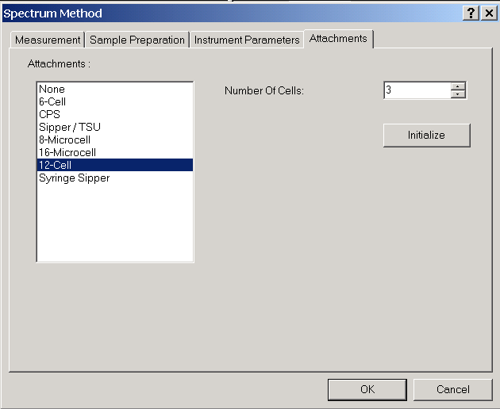
  - Click on the Measurement tab. Enter the wavelength range you want to observe, between 900-190 nm. Change the Sampling Interval if you wish to acquire at a very high resolution (1.0 nm is typical of most spectra).
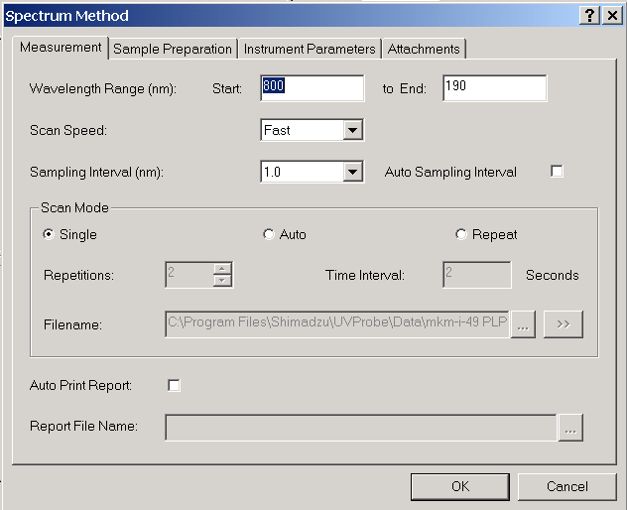
  - Click on the Instrument Parameters tab. Change the slit width if needed (0.5 nm is typical). If you are expecting an absorbance at the wavelength where the light source switches from visible to UV, change the switch wavelength as needed (between 282-399 nm). Typically 340 or 360 nm is used.
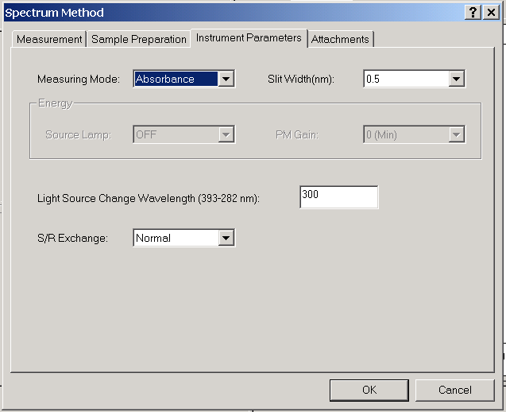
- Optional: Click on the Sample Preparation tab. You may enter additional information such as sample weight and dilution volume here.
- Click on the OK button when done setting up the method.
- Place two cuvettes of solvent in the cell holder and click .
- Click to zero over the entire wavelength range. This may take a few minutes.
- Remove the cuvette filled with solvent from the frontmost cell holder. The front cell holder is the sample holder.
- Place your cuvette filled with sample in the front cell holder.
- Click on to start acquisition.
- When the acquisition is complete you will be asked for a filename.
- To autoscale your spectrum, right-click on the spectrum plane and select autoscale.
- To perform peak-picking click on or go to Operations → Peak Pick.
The software automatically selects both peaks and valleys. If you wish to see only peaks, right-click on the peak/valley table and deselect “Show Valleys” and “Mark Valleys”.
- To observe your spectrum as numerical raw data suitable for exporting into Excel, click the Data Print icon. If necessary, right-click on the data table and select Properties to adjust the wavelength range to be sure all data is generated in the table. Highlight the data. Copy and paste the data into Excel if desired.
- To print your spectrum and peak list as a report, click on Window → Report Generator.
  - Click on File → Open and select the file “Spc Peak Pick”.
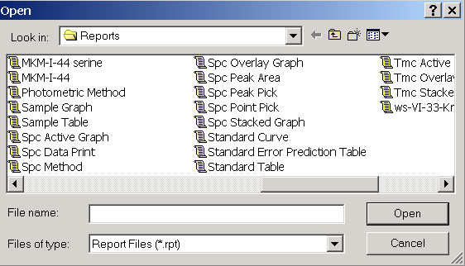
  - Click on File → Print to print the report.
- Click on the icon to return to spectrum mode.
- To save your data click on File → Save.
- To clear your spectrum and acquire new data, click on File → Properties. Select your file and then click on the Delete button. NOTE: Be sure your file is saved before you click Delete or all data will be lost!!
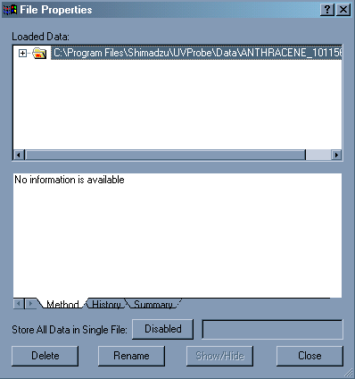
- When you have finished acquiring all your spectra, remove your cuvettes.
- Click the button.
- Exit the UV Probe software.
- Turn off the UV instrument.

