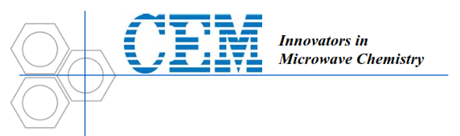
Quick-Start Guide 2/21/2014 Beth Donovan
- Obtain the carousel and unlock the plastic top.
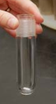
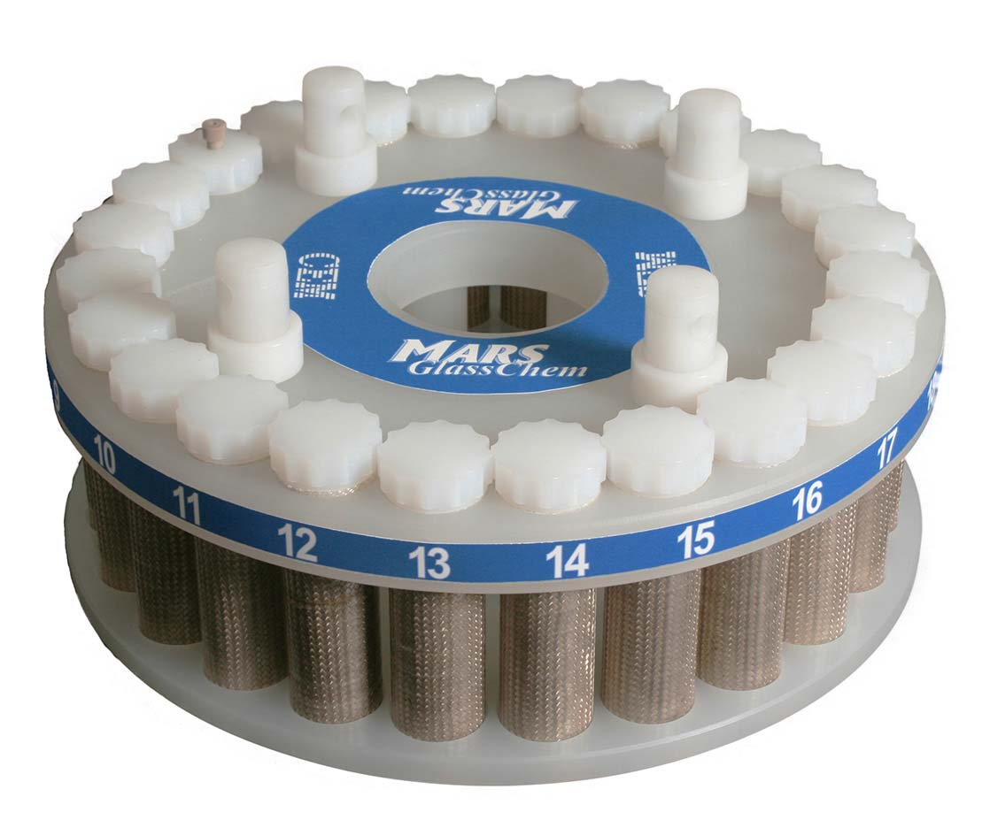
- Identify the “sensor” vessel (the one with the hole on top). Place solvent, stir bar, and the sapphire well inside, and load this vessel into position 1.

- Prepare other GlassChem vessels as desired, and load into positions such that the carousel is balanced.
Note: Use the Teflon torque wrench to “snap” the tops securely into place on each vessel.
- Replace the plastic top onto the carousel.
- Plug in the microwave and place the exhaust line into a fume hood.
- Insert the carousel (line up the “D” shape on the bottom of the carousel with the “D” inside the oven).
- Obtain the temperature probe (the long blue fiber optic piece). Remove the white cap from the temperature probe and insert into the top hole of the microwave. Put the other end of the temperature probe into the large hole atop microwave, threading it through, and push it down into the bottom of the “sensor” vessel.
- Close the microwave door.
- Use the touch screen to create a method (if desired) or use an existing method.
Note: Touch and hold a method icon to edit a method. Use the save icon (top right corner) to save a method as needed.
- Check that the turntable is unobstructed by pressing the circular arrow icon. (Be sure the sensor probe doesn’t catch and pull out)
- Run the microwave as desired.
Other notes:
To use the “EasyPrep” vessels (the large Teflon ones), obtain the pressure sensor (the light blue rubber tubing device). Plug the pressure sensor into the side of the microwave and screw the other end into the “sensor” vessel and clamp the hose into the top of the interior of the microwave. All other procedures are same as above.
For method development: Suggested volumes, temperatures, pressures, and reaction times are given in detail for various solvents in the “ChemGlass Operation Manual” and “MARS6 User Guidelines”.

